CPI PACAKGES
DEV-PERF
The below Packages from CPI-DEV to CPI PERF

PNG_CUSTOMER_S4_ISU_SVO
PNG_CUSTOMER_S4_ISU_PRS
PNG_CUSTOMER_S4_ISU_CS
PNG_CUSTOMER_S4_ISU_SVO_ESR
PNG_CUSTOMER_S4_ISU_PRS_ESR
PNG_CUSTOMER_S4_ISU_CS_ESR
Account Explorer - Duke Energy Business Services LLC - SAP BTP Cockpit
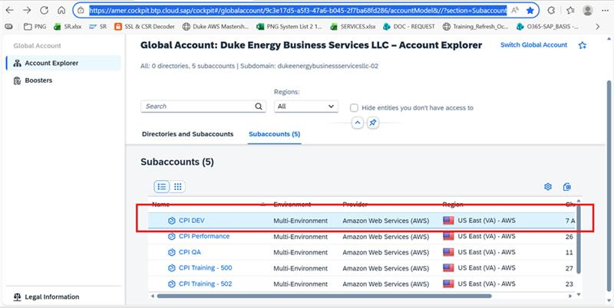
Click on CPI DEV
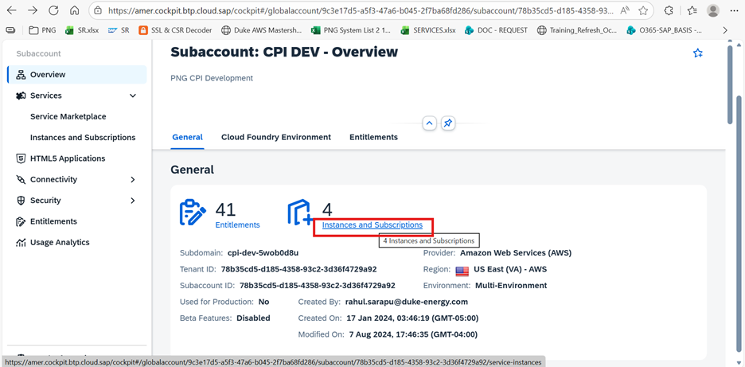
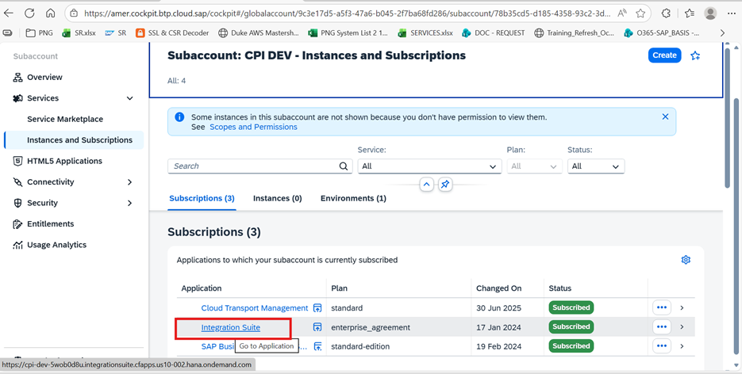
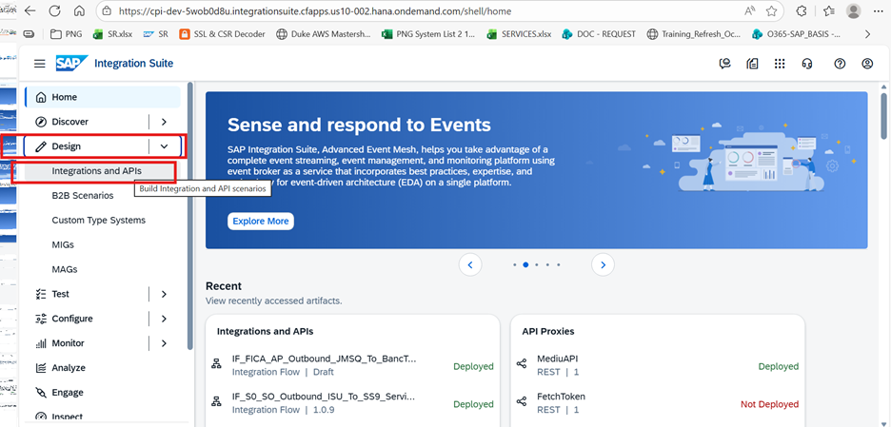
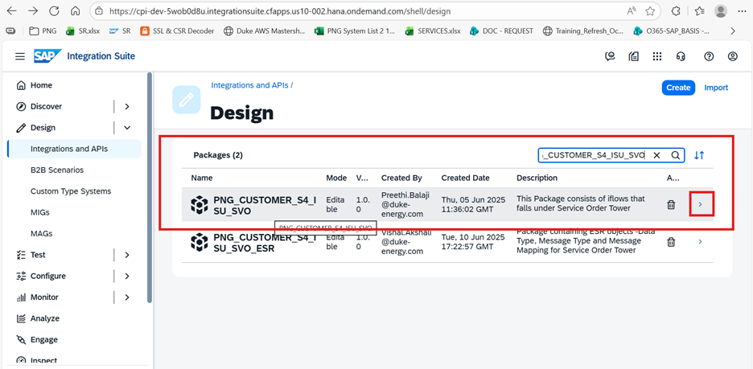
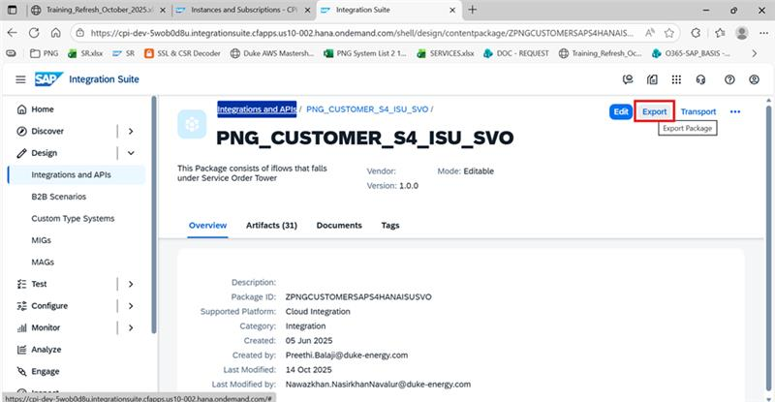
After export all packages in folder download
now import to perf
